**Ideation Phase**

**Empathize & Discover**

|  |  |
| --- | --- |
| Date | 13 june 2025 |
| Team ID | LTVIP2025TMID32074 |
| Project Name | Sustainable Smart City |
| Maximum Marks | 4 Marks |

**Empathy Map Canvas:**

**An Empathy Map is more than a tool — it’s a window into your user’s world.  
It helps teams visualize what users see, hear, think, feel, say, and do, enabling a deeper understanding of their challenges and goals.**

**By stepping into the shoes of your user, you uncover insights that are essential for crafting meaningful solutions.  
This process strengthens user-centered thinking and fosters greater innovation.“To design a great solution, you must first understand the person who needs it.”**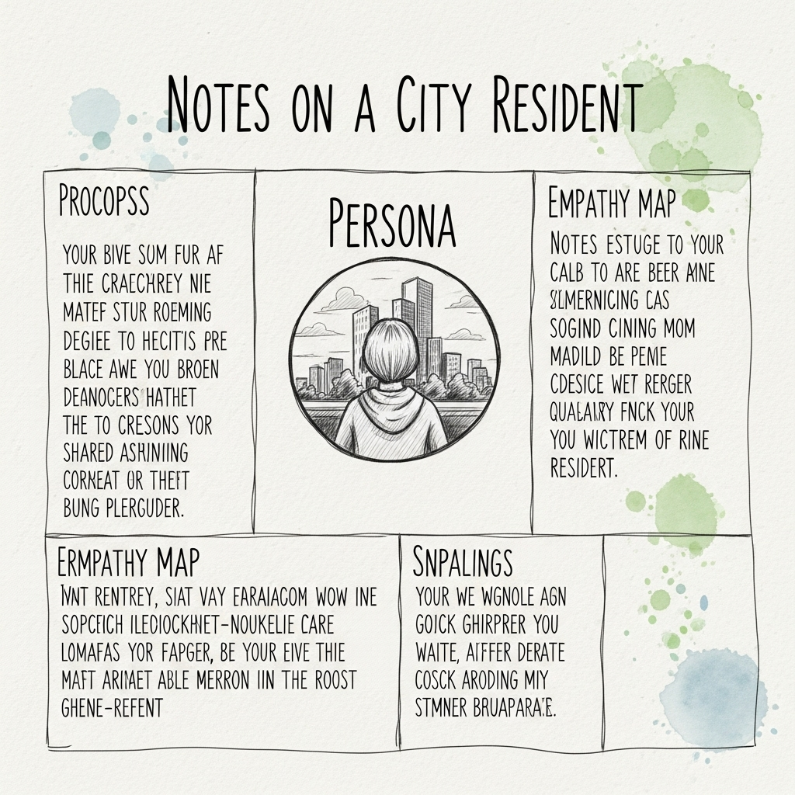

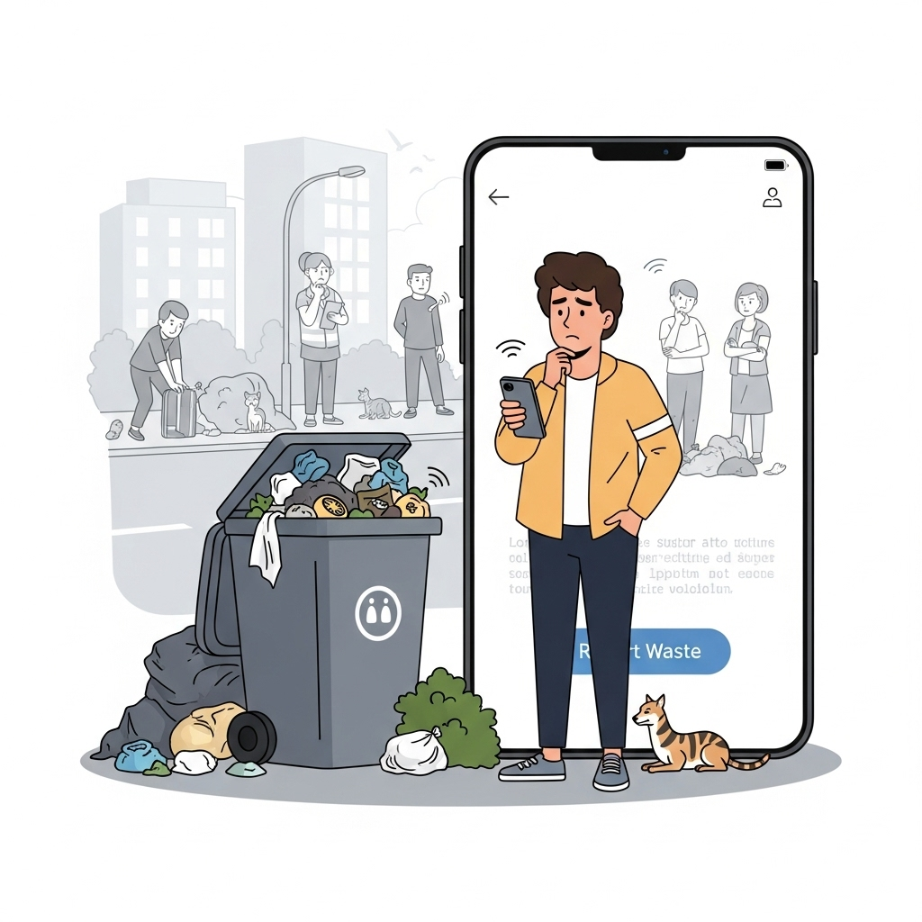

**Example Use Case: Smart City Waste Reporting App**

Imagine you're designing a mobile app for citizens to report waste collection issues in their area. Think from the user's perspective:

* **Sees:** Overflowing garbage bins, dirty streets, no nearby waste collection schedules displayed
* **Hears:** Neighbors complaining about the bad smell and slow municipal response
* **Thinks & Feels:** “Will the municipality even respond if I report this?” — Feels ignored, frustrated
* **Says & Does:** "I'll report it, but I doubt they’ll fix it soon." — Takes a photo, hesitates to submit the complaint